Keith Jeffery and military history
I am very grateful to the Ulster Society for Irish Historical Studies for inviting me to speak about Keith, military history, and Ireland. My own knowledge of military history is somewhat limited, having squandered my youth studying the interwar British armed forces’ most pernicious foe, HM Treasury, and what I do know is partly what I learned from Keith over the years since 1981.

In some respects Keith Jeffery was not a proper military historian at all. Tanks don’t clank through every chapter, the relative merits of British and French artillery or medium machine guns may be mentioned but are left unexplored in detail. He is similarly cavalier in his passing treatment of cap badges, decorations, regimental traditions, pig-sticking and other matters which, as anyone who visits, say, the bookshop in the National Archives in Kew will testify, form the mass of what is popularly classified as military history. Nor, despite his work on Henry Wilson, was he fixated with high command.

He knew and understood military custom –I recall him gently explaining to me that anyone who held a commission in the Kings Royal Rifle Corps during the Second World War as SOE’s Irish agent Roddy Keith did must have had a handsome private income - but this knowledge informed rather than dominated his research and his writings. Keith was interested both in the planning of and conduct of war at the highest levels, and in the impact of such decisions – and indecisions – on the people expected to do the fighting, the killing and the dying, and on the communities from which they came and to which, even after the horrors of Flanders, Gallipoli and Mesopotamia, the great majority returned more or less sound in soul and limb.

Keith was also fascinated by the paradoxes of peacetime, where demands upon the military in some respects increased across the empire, not only because of what he termed ‘the Irish ulcer’ (not to be rendered as ‘ulcer will fight …). His Cambridge PhD and his second book, The British Army and the crisis of empire 1918-22, explored imperial strategy at the highest level immediately after the Great War. It was a moment when the greatest visible threats came from within, amongst the discontented subject peoples of an empire on which the sun never set, while the new intangible menace of Bolshevism, an ideology almost without an army, appeared to pose an existential threat to the world order established by victory in 1918.

His final book, 1916: a global history, drew ‘into the narrative sometimes marginalised participants in the war, non-combatants as well as soldiers, women as ell as men’ (p. 3). It would be wrong to see this as evidence of an inexorable progression on Keith’s part, a kind of creeping barrage towards the prevailing wisdom of misery and despair which leaves one with no rational exploration whatsoever while countries, armies and individual warriors made choices to fight, and to fight again: rather, from the start of his career Keith was also, in contrast to some who focus on the cultural and the human impacts of war, emphasising the pointlessness and the waste, interested in people who saw military life as a legitimate and even fulfilling as well as a necessary calling, who enjoyed the fight, who did not look back on combat, injury and loss in sorrow and terror but with something approaching relish and nostalgia (my friend Brian Stewart (1923-2015) told me that, notwithstanding the death of his only sibling in Sicily in 1943, his own wounding and the destruction of his entire anti-tank platoon at Rouray in Normany in 1944, he would have remained in the Black Watch after the war but did not have the necessary private income).

Keith understood such people, their motivations and experiences just as he did those who found armed service traumatic and unbearable. And he understood the preoccupations and the motivations of those involved in higher command, of making, amending and abandoning grand strategy, just as he did the poor bloody infantry who had to do the fighting,

As I already mentioned, Keith’s writing about the military is infused with a deep appreciation of and understanding of military culture. This is reflected in the relish with which he catalogued and later edited the papers of the Longford man Sir Henry Wilson, that most political of twentieth century Irish soldiers, as chief of the imperial general staff from 1918 to 1922. This work of meticulous scholarship was, hard to believe as it may seem, completed using index cards and without any of the modern tools of research and scholarship – laptop, camera, spreadsheets, laser printer, databases - without which most historians today would be paralysed. In it he displayed his interest not only in problems of strategy and personnel, of civil/military relations and aid to the civil power to break strikes and suffocate incipient Bolshevism, of unbearable ‘frocks’ and unspeakable – though in Wilson’s view not necessarily un-beatable - Irish rebels, of imperial overstretch and of all the other matters with which Wilson had to wrestle, but in human questions: demeaning pleas for preferment, taking the axe to dead wood, Neville Macready’s insistence on £5,000 ‘table money’ for taking over in Ireland, and so on (Keith himself spent plenty on his own table, to the great benefit of those who enjoyed his and Sally’s hospitality at 88 Eglantine Avenue).

Keith’s most important contributions to military history in Ireland are, as demonstrated in his reflections in Ireland and the Great War, his insistence upon exploring Irish experience within a wider imperial and global framework. From his first book to his last, Irish issues are rightly viewed through the larger prisms of imperial and global history.

To conclude: one problem with libraries is their callous treatment of dust jackets. Most students who consult Keith’s work are consequently deprived of the pleasure of their meticulously chosen cover illustrations. A possible exception is the first book which he published under his own name, the co-authored work States of Emergency: British Governments and strike-breaking since 1919 (1983). Even there, however, the key image is positioned at a strikingly rakish angle.
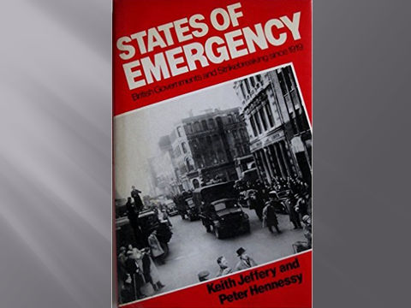

Not for him the awkward abstractions or literal reading of some poorly briefed jacket designer: in later works such as Men, Women and War, Ireland and the Great War, A Military History of Ireland, The GPO and the 1916 Rising and Sir Henry Wilson: a political soldier, contemporary art rather than photographs or abstract designs adorn the covers. Where appropriate his books also included wonderful maps, proof positive of his strategic foresight in marrying Sally.

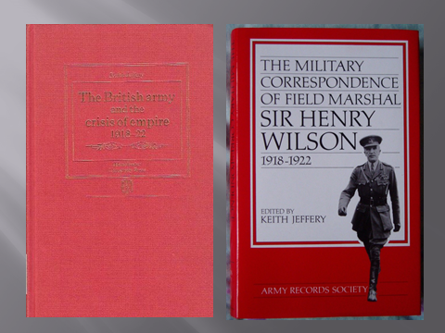

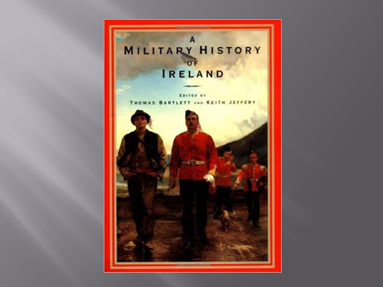

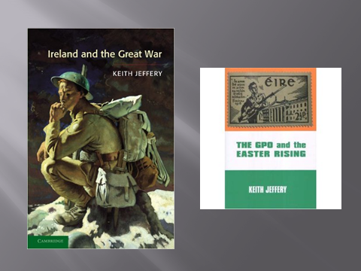

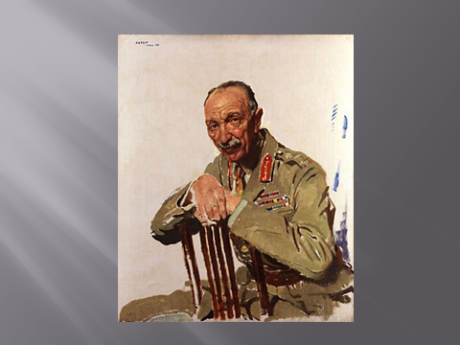

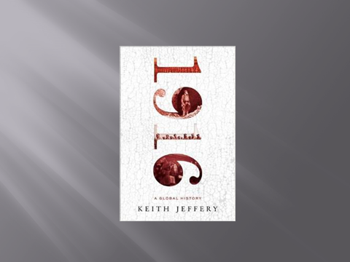
The only explicitly military work of Keith’s of which I have been unable to find an image of the cover is Men, Women and War: Historical Studies XVIII, the proceedings of the 19th Irish conference of historians, which he edited with his University of Ulster colleague and friend Tom Fraser. It was not for the want of trying. Last night I used that arcane research tool Google to look for an image of the cover of Men, Women and War. I leave you with a screen shot of the results, of which I hope Keith at least would have thoroughly approved:

