DREADFUL MONSTERS AND POOR RELATIONS: THE DEBATE OVER IRISH PUBLIC FINANCES, 1801-1914.
Julian Hoppit, UCL
USIHS Lecture, Thursday 6 February 2020 at 7pm, PRONI
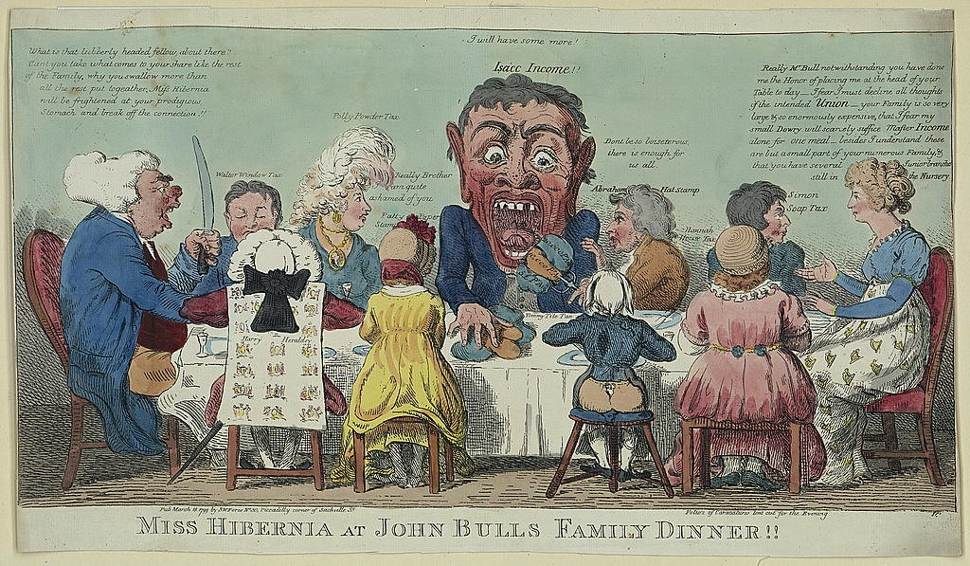

There is nothing new in the centrality of fiscal matters to the functioning of the UK as a composite state of four nations and many regions, each with different resources, histories and hopes. Settling public finances were front and centre in the unions of 1707 and 1801 as well as at the partition of Ireland in 1921 and the establishment of the Irish Free State, while Northern Ireland’s customs arrangements proved to be the main sticking point in implementing Brexit. Yet such constitutional turning points rarely settled questions about the territoriality of public finances for long. In particular complaints that the union was fiscally inequitable have been raised time and again over the centuries. Whatever the ingenuity of politicians and civil servants, no balm has been able to cure this itch.
Crucially, the UK has always been significantly unbalanced in two main ways: England has been very much larger territorially, demographically and economically; and secondly London has been an unusually large and powerful capital tucked away into its south-east corner, closer to Paris, Amsterdam and Brussels than to Edinburgh, Dublin or Newcastle. Furthermore, England’s predominance and London’s power were intimately tied to changing regional rather than national economic fortunes over time, through the industrial revolution and then deindustrialisation, associated with the rise and fall of a global empire.
At heart questions about the territoriality of the UK’s public finances can be understood in terms of the struggle between two opposing myths, alluded to in the first half of my peculiar title. After the Anglo-Scottish Union of 1707 one crude piece of Scottish doggerel described the agents of the new tax state there as a ‘dreadfull monster’, with London draining the nation through additional and burdensome exactions. Claims that London has impoverished and stunted the distant parts of the United Kingdom have been made frequently since, both in terms of siphoning off provincial wealth and tailoring policies to the capital’s distinctive circumstances and preoccupations, in part because of ignorance of what was once called ‘outer Britain’.
Tellingly, this monster was revived in a cartoon in 1799 as talk of a union of Britain and Ireland grew louder. On the right is depicted calm femininity, Miss Hibernia; facing her on the far left is her suitor, a ruddy, gesturing, John Bull, perhaps in his cups. Between them are his family, identified as various taxes, complaining that the central figure, the monstrous income tax, first collected in 1799, has an insatiable appetite. Understandably, Hibernia rejects marrying into such a dysfunctional household. Such views were commonplace at the time. John Foster, Speaker of the Irish House of Commons, put it bluntly to his MPs: though William Pitt, the Prime Minister, was a financial wizard, ‘he wants your purse and your trade’, warning that ‘New laws, equal in appearance and phrase, may be very unequal in effect.’
The opposing myth is that the provinces have been like poor relations, begging for aid or special treatment: ‘a drain on your purse, a drawback upon success, a rebuke to your rising’, and that far from being a fantastical ogre London is a golden goose benefitting the whole Union. This myth holds that some parts of the UK provide much less tax revenue than might be expected and/or have been subsidised by much higher levels of public expenditure.
A history of the role of public finances in the waxing and waning of the UK has to explore the interplay of geographical circumstances (economic life and culture especially), politics and principles. The key principles are equality and equity, though economy and efficiency are also important. Equality holds that all members of a state should be dealt with uniformly, come what may; the principle of equity looks for those members to be dealt with fairly, according to their means and needs. These principles do not always align in practice, and not just because assessing fairness is rarely straight forward. Equality is predicated on the belief that all citizens have some inherent rights, most obviously to the state’s protection, and obligations, most obviously in this context to pay taxes. But because people’s circumstances can vary hugely, to be fair public finances may have to be tailored considerably, that is unequally: depending on their circumstances some people are more or less able to pay taxes and more or less needful of public goods. Today we expect taxes to be the same across the UK, but for equity to be produced by using public expenditure in a redistributive way. Despite what is commonly said, the first principle was not well established until 1858. The second only really began to take hold from 1870 and had made only limited headway by 1914.
In the nineteenth century Ireland came to contribute considerably more to the Exchequer in London than might have been expected, especially after the Great Famine. This was caused by a breakdown of the fiscal terms of the Union within twenty years and a significant change of British tax policy towards Ireland in the 1850s, in the context of an economy that was more resilient than is often allowed: Gladstone and others insisted that in terms of taxation Ireland had to be treated pretty much like the rest of the United Kingdom. Such an insistence generated voluminous complaints in Ireland that it was over taxed, fuelling calls for Home Rule and independence. As such this requires adjusting current interpretations that have emphasized the building of trust between central government and citizens as a distinctive hallmark of the British state.
In 1801 Ireland supplanted Scotland in relative importance within the fiscal Union; by 1830 Scotland had taken that palm. On the eve of the Famine Scotland was clearly flourishing within a political economy which, since the 1780s, some of its people had played a prominent role in framing. But if in the late eighteenth century policy makers in London had reacted positively to some Scottish criticisms of the fiscal state, from the 1830s they were generally reluctant to take on board complaints that their system was ill-suited to Ireland’s distinctive circumstances. With a rising tax take from Ireland after the Famine, that was somewhat understandable. A high degree of equality of taxation was, in certain respects, clearly successful. But complaints that this was inequitable to Ireland did gradually make an impact. The response, though, was not to change the tax regime, but to maintain a notably more preferential balance between UK taxpayers and local ratepayers in Ireland, and to begin to spend large amounts of UK revenue on the land question especially, again, in Ireland. This, though, failed to convince many in Ireland that the taxing Union was anywhere near fair. To them, equal taxation produced a tax regime that was markedly more regressive than in Britain, while creaming off ever more taxation as Ireland’s population shrank just seemed plain wrong. In those circumstances, agreement on questions of public finance was impossible. Fiscally, the Union had, simultaneously, worked and failed.

